**Testing and Evaluation**

The testing is done to check the performance of an application and how it functions. The test results of the “Improve Speech” application is illustrated below:

1. Test 1

|  |  |
| --- | --- |
| Objective | To test fields with empty data in login page |
| Expected Result | Error message should be displayed |
| Actual Result | Error message displaying Username and Password field is required |
| Conclusion | Pass |

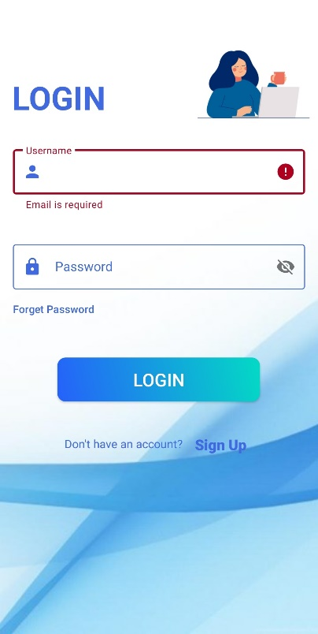 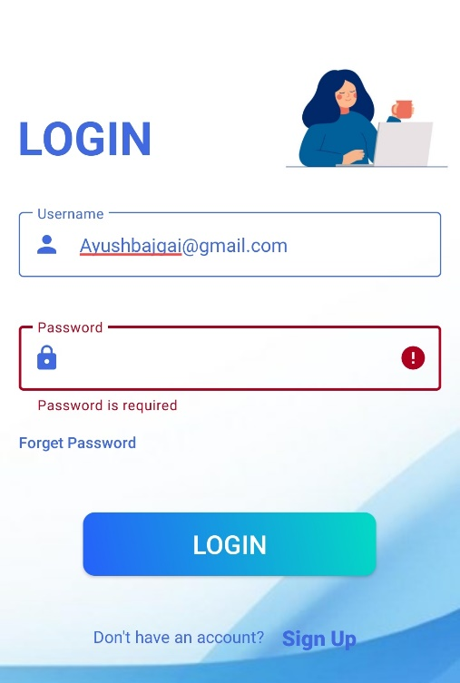

*Fig 1: (Test 1) Empty field required message*

1. Test 2

|  |  |
| --- | --- |
| Objective | To test user can login with invalid email and password |
| Expected Result | Error message should be displayed |
| Actual Result | Error message displaying Invalid Username and Password |
| Conclusion | Pass |

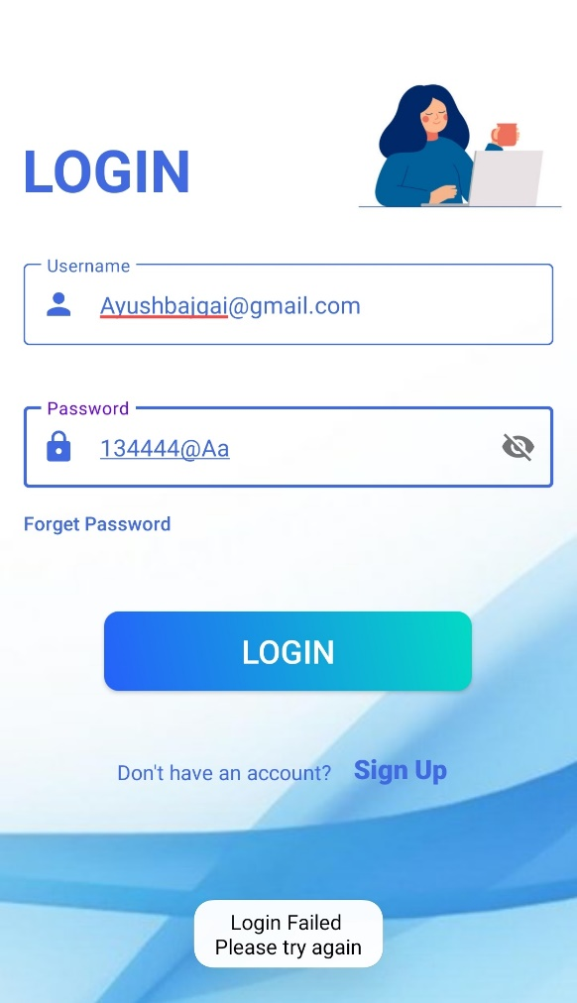

*Fig 2: (Test 2) Login Failed Message*

1. Test 3

|  |  |
| --- | --- |
| Objective | To test fields of password validation in login page |
| Expected Result | Error message should be displayed |
| Actual Result | Error message displaying :   * Password must contain 1 capital letter * Password must contain 1 small letter * Password must contain 1 numeric value * Password must contain 1 special character * Password shouldn’t be less than 6 characters |
| Conclusion | Pass |

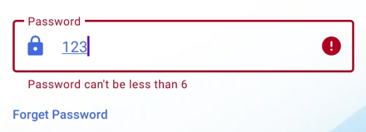 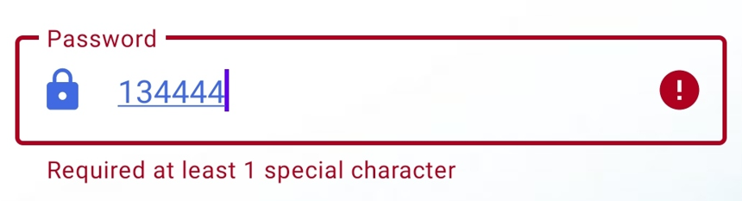

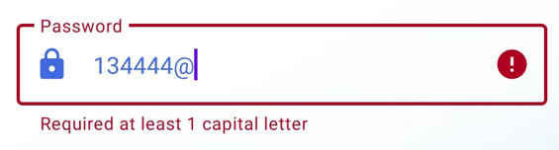 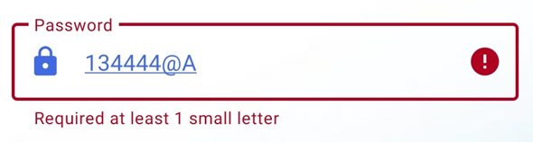

*Fig 3: (Test 3) Password validation error message*

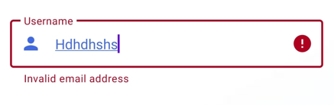

*Fig 4: (Test 4) Invalid email error message*

1. Test 4

|  |  |
| --- | --- |
| Objective | To test fields of email validation |
| Expected Result | Error message should be displayed |
| Actual Result | Error message displaying:   * Invalid email address |
| Conclusion | Pass |

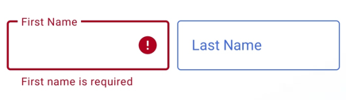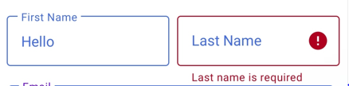

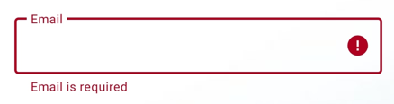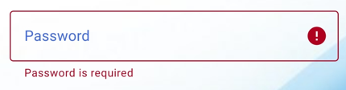

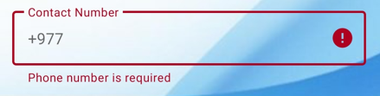 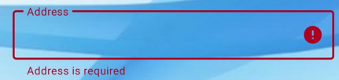

*Fig 5: (Test 5) Field required error message*

1. Test 5

|  |  |
| --- | --- |
| Objective | To test fields with empty data in Register page |
| Expected Result | Error message should be displayed |
| Actual Result | Error message displaying:   * First Name is required * Last Name is required * Username is required * Password is required * Confirm password is required * Contact number is required * Address is required |
| Conclusion | Pass |

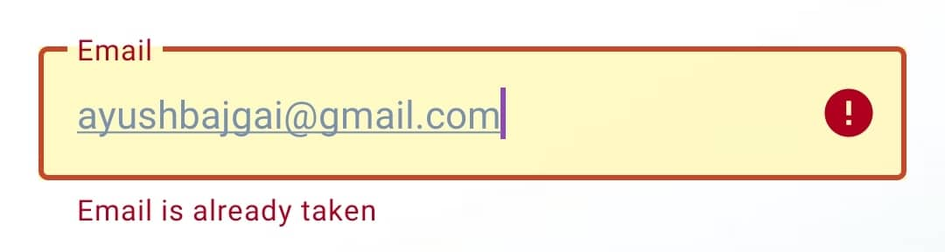

*Fig 6: (Test 6) Email taken error message*

1. Test 6

|  |  |
| --- | --- |
| Objective | To test the user trying to register with same email address |
| Expected Result | Error message should be displayed |
| Actual Result | Error message displaying :   * Email has already been registered |
| Conclusion | Pass |

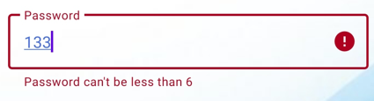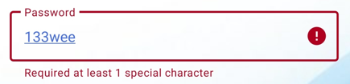

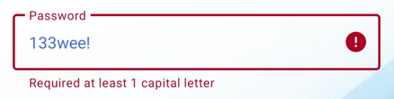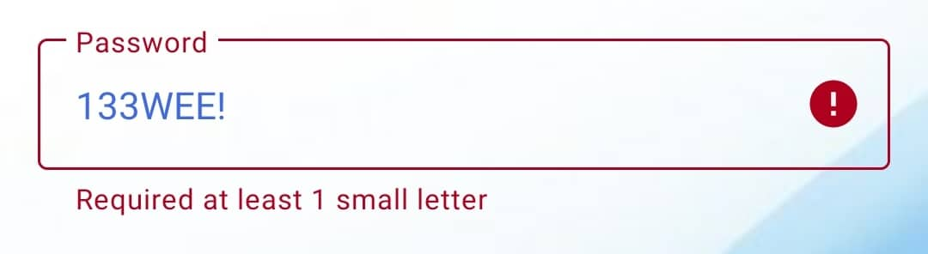

*Fig 7: (Test 7) Register password validation error message*

1. Test 7

|  |  |
| --- | --- |
| Objective | To test fields of password validation in register page |
| Expected Result | Error message should be displayed |
| Actual Result | Error message displaying :   * Password must contain 1 capital letter * Password must contain 1 small letter * Password must contain 1 numeric value * Password must contain 1 special character * Password shouldn’t be less than 6 characters |
| Conclusion | Pass |

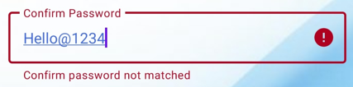

*Fig 8: (Test 8) Confirm password not matched error message*

1. Test 8

|  |  |
| --- | --- |
| Objective | To test confirm password and password when written incorrectly |
| Expected Result | Error message should be displayed |
| Actual Result | Error message displaying:   * Confirm Password not matched |
| Conclusion | Pass |

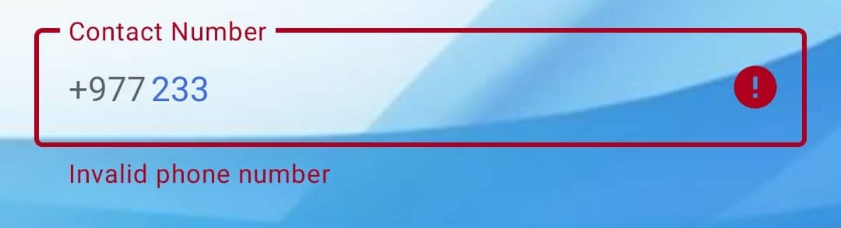

*Fig 9: (Test 9) Invalid phone number error message*

1. Test 9

|  |  |
| --- | --- |
| Objective | To test fields of contact number validation |
| Expected Result | Error message should be displayed |
| Actual Result | Error message displaying:   * Invalid phone number |
| Conclusion | Pass |

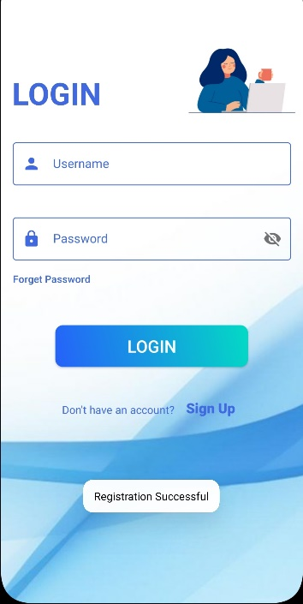

*Fig 10: (Test 10) Registration Successful message*

1. Test 10

|  |  |
| --- | --- |
| Objective | To test user registered |
| Expected Result | Success message should be displayed and redirects user to Login page |
| Actual Result | Success message displaying:   * Registration Successful |
| Conclusion | Pass |

1. Test 11

|  |  |
| --- | --- |
| Objective | To test user login credentials |
| Expected Result | Success message should be displayed and redirects user to Dashboard page |
| Actual Result | Success message displaying:   * Login Successful |
| Conclusion | Pass |

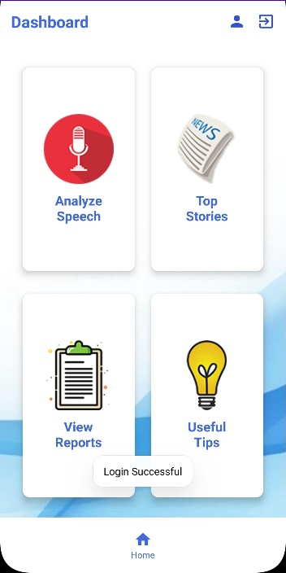

*Fig 11: (Test 11) Login Successful message*

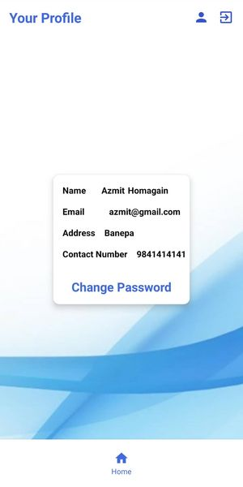

*Fig 12: (Test 12) View user info*

1. Test 12

|  |  |
| --- | --- |
| Objective | To test user can view their profile |
| Expected Result | User can view their details on profile page |
| Actual Result | Displays user profile and information |
| Conclusion | Pass |

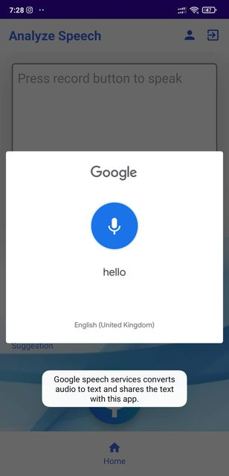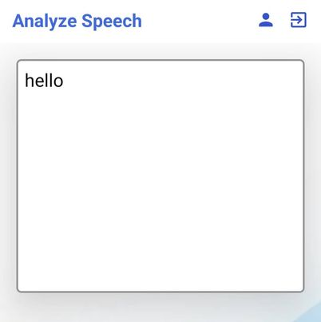

*Fig 13: (Test 13) Transcribes speech to text*

1. Test 13

|  |  |
| --- | --- |
| Objective | To test user speech can be transcribe to text |
| Expected Result | User voice should be transcribed to text input |
| Actual Result | Successfully transcribes user speech into text form |
| Conclusion | Pass |

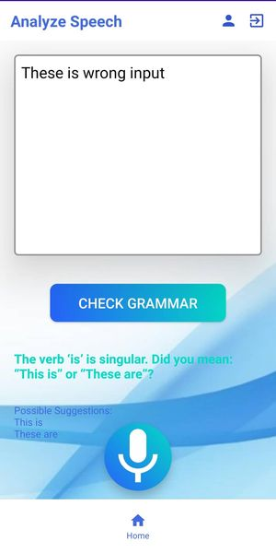

*Fig 14: (Test 14) Displaying description and suggestions*

1. Test 14

|  |  |
| --- | --- |
| Objective | To test user grammar |
| Expected Result | Clicking on Check Grammar button provides description and suggestions to user grammar |
| Actual Result | Successfully provides suggestions and description message to the user |
| Conclusion | Pass |

1. Test 15

|  |  |
| --- | --- |
| Objective | To test user can view their report |
| Expected Result | User can view their profile on View Report page |
| Actual Result | Displays Report to user |
| Conclusion | Pass |

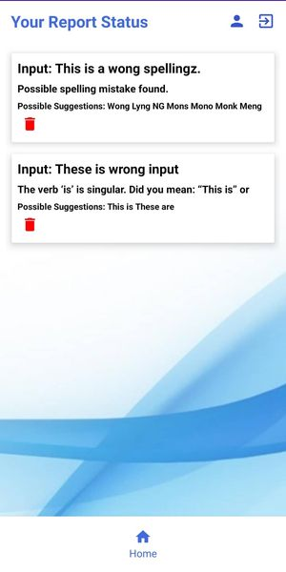

*Fig 15: (Test 15) Displaying User grammar reports*

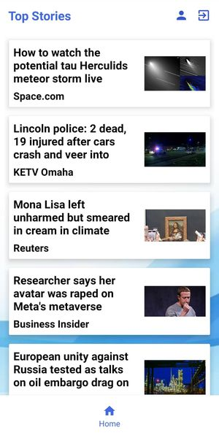

*Fig 16: (Test 16) Displaying News reports*

1. Test 16

|  |  |
| --- | --- |
| Objective | To test user can view top stories |
| Expected Result | User can view top stories on Top Stories page |
| Actual Result | Displays top stories to user |
| Conclusion | Pass |

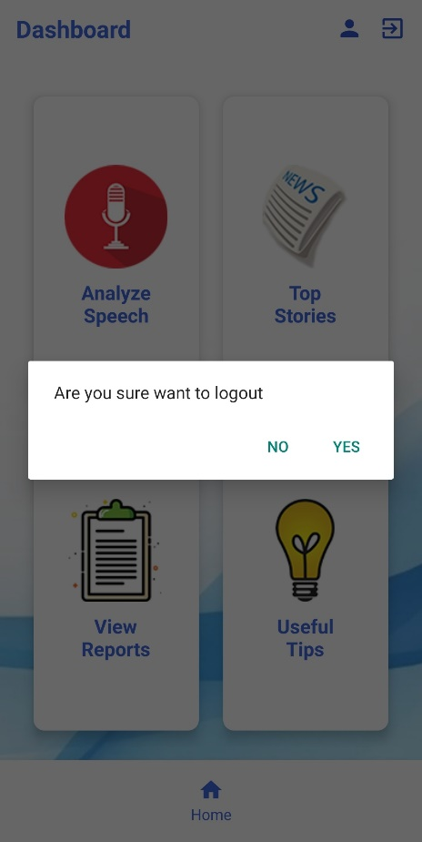

*Fig 17: (Test 17) Logout message*

1. Test 17

|  |  |
| --- | --- |
| Objective | To test user should terminate from the system |
| Expected Result | Clicking on exit icon and again clicking on Yes message logs out from the system and redirects user to login page |
| Actual Result | Logs the user out from the system |
| Conclusion | Pass |